SEMESTER ONE
Papers written by
Australian Maths Software

YEAR 12

MATHEMATICS METHODS

Unit 3

2017

Section One
(Calculator–free)

Name: _________________________________

Teacher: _______________________________

TIME ALLOWED FOR THIS SECTION

Reading time before commencing work: 5 minutes
Working time for section: 50 minutes

MATERIAL REQUIRED / RECOMMENDED FOR THIS SECTION

To be provided by the candidate
Standard items: pens, pencils, pencil sharpener, highlighter, eraser, ruler.

IMPORTANT NOTE TO CANDIDATES

No other items may be taken into the examination room. It is your responsibility to ensure that you do not have any unauthorised notes or other items of a non–personal nature in the examination room. If you have any unauthorised material with you, hand it to the supervisor before reading any further.

To be provided by the supervisor

Question/answer booklet for Section One.
A formula sheet which may also be used for Section Two.
Structure of this examination

 | Number of questions available | Number of questions to be answered | Working time (minutes) | Marks available | Percentage of exam
Section One  Calculator—free | 7 | 7 | 50 | 52 | 35
Section Two  Calculator—assumed | 13 | 13 | 100 | 98 | 65
Total marks |  |  |  | 150 | 100

Instructions to candidates

1. The rules for the conduct of this examination are detailed in the Information Handbook.
Sitting this examination implies that you agree to abide by these rules.

2. Write your answers in the Question/Answer booklet.

3. You must be careful to confine your responses to the specific questions asked and to
follow any instructions that are specific to a particular question.

4. Spare pages are provided at the end of this booklet. If you need to use them, indicate
in the original answer space where the answer is continued i.e. give the page number.

5. Show all your working clearly. Your working should be in sufficient detail to allow your
answers to be checked readily and for marks to be awarded for reasoning. Incorrect
answers given without supporting reasoning cannot be allocated any marks. For any
question or part question worth more than two marks, valid working or justification is
required to receive full marks. If you repeat an answer to any question, ensure that you
cancel the answer you do not wish to have marked.

6. It is recommended that you do not use pencil, except in diagrams.

7. The Formula Sheet is not to be handed in with your Question/Answer booklet.

1. (8 marks)
(a) Find and simplify the expression for each of the following
(i) (2)

(ii) (3)

(b) Given find (3)

2. (9 marks)
Evaluate the following
(a) (3)

(b) (2)

(c) (1)

(d) (3)

3. (7 marks)
(a) Two hundred and fifty randomly selected students were surveyed to determine if
an overseas trip for students should be planned for students in Year 10, or in
Year 11 or in Year 12.

The results are in the table below.
Year | 10 | 11 | 12
Preference | 90 | 90 | 70

(i) Convert the data to form a probability density function. (2)
 | 10 | 11 | 12

(ii) If two students from the school were selected at random, what is the
probability that they both thought Year 12 students should not go on an
overseas trip. (2)

(b) Which of the following represents a probability density function?
Give your reasons. (3)
(i)
x | 0 | 1 | 2 | 3
P(X = x) | 0.1 | 0.2 | 0.3 | 0.4

(ii)
x | 10 | 11 | 12 | 13
P(X = x) | 0.2 | 0.3 | 0.1 | 0.5

(iii)
x | 6 | 7 | 8 | 9
P(X = x) | 0.4 | 0.5 | -0.3 | 0.4

4. (6 marks)
(a) Find the area between the function and theaxis. (3)

(b) Write down the expression for the area between the functions that is illustrated in the diagram below. (3)
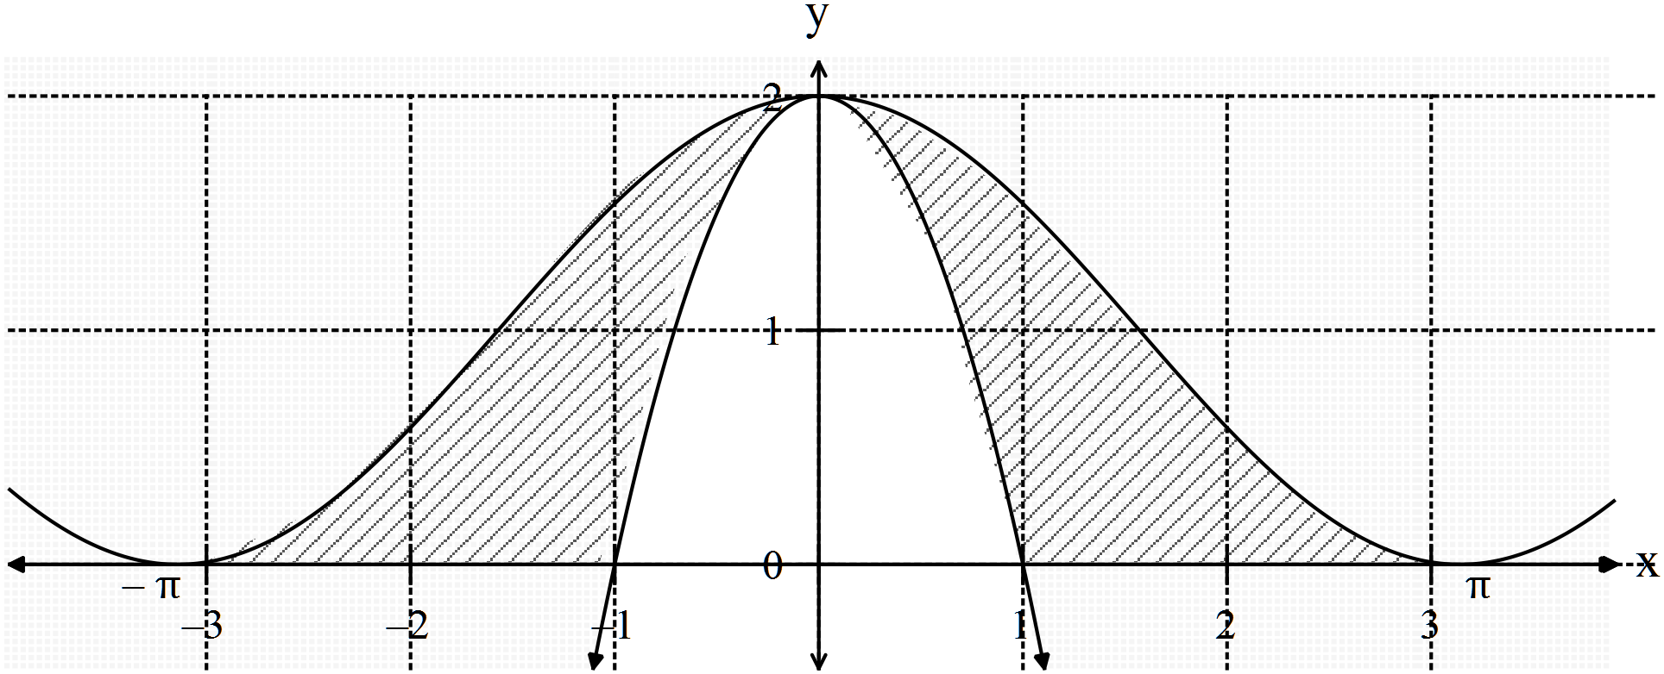

5. (9 marks)
The acceleration of a particle is given by for and it is known that
and
(a) Find the velocity and the displacement equations. (4)

(b) Hence find the velocity and displacement at (2)

(c) Find when the particle changes direction. (3)

6. (10 marks)
The height of a piston is given by where is measured in
metres and in seconds.

(a) Sketch the height of the piston on the set of axes below for (2)

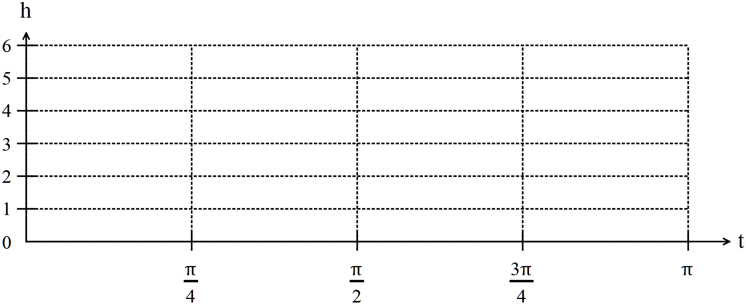

(b) At what rate is the piston rising at ? (2)

(c) Explain using the graph in (a) why your answer to (b) gives the maximum
rate of rise of the piston. (3)

(d) At what rate is the velocity of the piston changing at ? (3)

7. (3 marks)
Given that show that
Hint: Use (3)

END OF SECTION ONE
Extra page for working if necessary

